 | Name of Teaching Staff | JASWINDER SINGH SRAN |  |  | 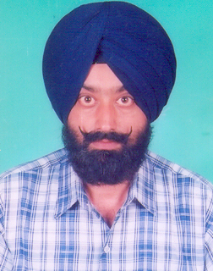
 | Designation | ASSOCIATE PROFESSOR
 | Department | ELECTRICAL ENGINEERING
 | Date of joining | 02.08.1988
 | Qualification with class/Grade | M.E (Systems& Drives) |  | 1st Div.
 | Total Experience Year | 27 Years
 | Papers Published | National Conference | International Conference |  |  | Journals
 |  | 18 | 06 |  |  | 04
 | Courses Attended | 22

 | Name of Teaching Staff | Dr. Yadwinder Singh Brar |  | 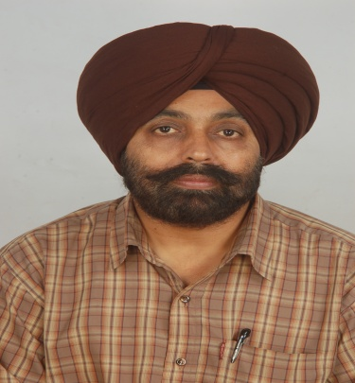
 | Designation | PROFESSOR
 | Department | ELECTRICAL ENGINEERING
 | Date of joining | 24.12.2008
 | Qualification with class/Grade | Ph.D.
 | Total Experience Year | 22Years
 | Papers Published | National Conference | International Conference |  | Journals
 |  | 24 | 36 |  | 25
 | Courses Attended | 17

 | Name of Teaching Staff | KHUSHDEEP SINGH SALANA |  |  | 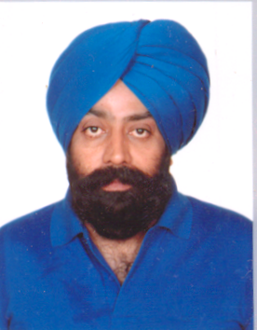
 | Designation | ASSOCIATE PROFESSOR
 | Department | ELECTRICAL ENGINEERING
 | Date of joining | 20.09.1990
 | Qualification with class/Grade | M.E (Electrical Engg.) |  | 1st Div.
 | Total Experience Year | 27 Years
 | Papers Published | National Conference | International Conference |  |  | Journals
 |  | 04 | 05
 | Courses Attended | 20

 | Name of Teaching Staff | Preetinder Singh |  | 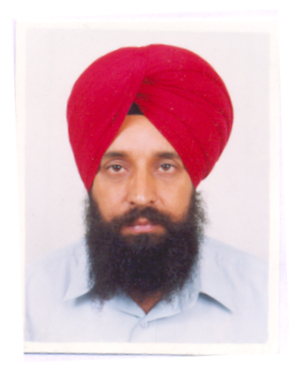
 | Designation | Associate Professor
 | Department | Electrical Engineering
 | Date of joining | 04-08-1997
 | Qualification with class/Grade | M.Tech(Electrical)/ Ist Division
 | Total Experience Year | 16 Yrs
 | Papers Published | 10
 | Papers Presented in Conferences | National Conference | International Conference |  | Journals
 |  | 06 | 04 |  | -
 | Courses Attended | 08

 | Name of Teaching Staff | Rupinderjit Singh |  | 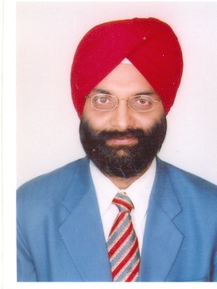
 | Designation | Associate Professor
 | Department | Electrical Engineering
 | Date of joining | 15-12-1995
 | Qualification with class/Grade | M.Tech(Electrical)/ Ist Division
 | Total Experience Year | 18Yrs
 | Papers Published | National Conference | International Conference |  | Journals
 |  | 06 | 03 |  | 02
 | Courses Attended | 13

 | Name of Teaching Staff | Dr. KANWARDEEP SINGH |  |  | 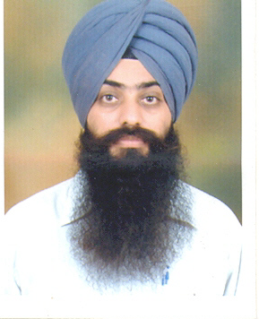
 | Designation | ASSISTANT PROFESSOR
 | Department | ELECTRICAL ENGINEERING
 | Date of joining | 22.08.2001
 | Qualification with class/Grade | Ph.D.
 | Total Experience Year | 15 Years
 | Papers Published | National Conference | International Conference |  |  | Journals
 |  | 05 | 10 |  |  | 06
 | Courses Attended | 13

 | Name of Teaching Staff | GAGANDEEP SINGH SODHI |  |  | 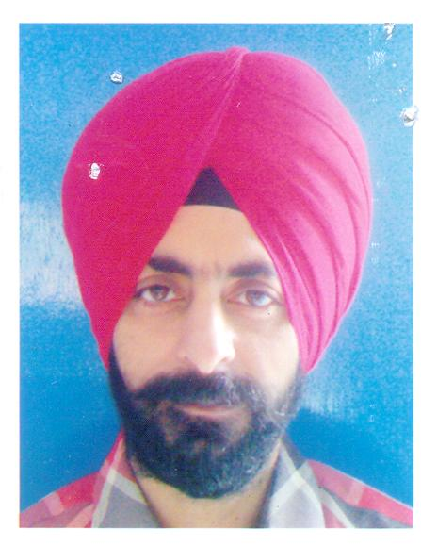
 | Designation | ASSISTANT PROFESSOR
 | Department | ELECTRICAL ENGINEERING
 | Date of joining | 02.02.2002
 | Qualification with class/Grade | M.TECH (Inst. & Contl.) |  | 1st Div.
 | Total Experience Year | 13 Years
 | Papers Published | National Conference | International Conference |  |  | Journals
 |  | 01 | - |  |  | -
 | Courses Attended | 14

 | Name of Teaching Staff | NAVNEET SINGH BHANGU |  |  | 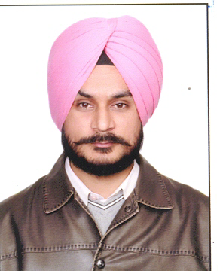
 | Designation | ASSISTANT PROFESSOR
 | Department | ELECTRICAL ENGINEERING
 | Date of joining | 11.9.2001
 | Qualification with class/Grade | M.TECH (Power Engg.) |  | 1st Div.
 | Total Experience Year | 12 Years
 | Papers Published | National Conference | International Conference |  |  | Journals
 |  | 18 | 05 |  |  | 05
 | Courses Attended | 12

 | Name of Teaching Staff | HARMINDER SINGH |  | 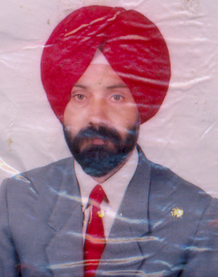
 | Designation | LECTURER (PP)
 | Department | ELECTRICAL ENGG.
 | Date of joining | 1.1.1980
 | Qualification with class/Grade | DIPLOMA (ECE) | 1st Class
 | Total Experience Year | 33 Years
 | Papers Published | Nil
 | Courses Attended | Nil

 | Name of Teaching Staff | CHARAN PREET SINGH GILL |  |  | 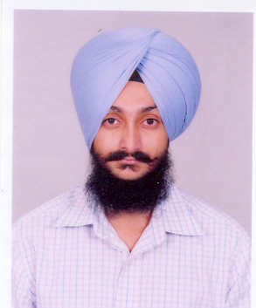
 | Designation | ASSISTANT PROFESSOR
 | Department | ELECTRICAL ENGINEERING
 | Date of joining | 17.01.2005
 | Qualification with class/Grade | M.TECH (Power Engg.) |  | 1st Div.
 | Total Experience Year | 09 Years
 | Papers Published | National Conference | International Conference |  |  | Journals
 |  | 08 | 03 |  |  | -
 | Courses Attended | 10

 | Name of Teaching Staff | HARMEET SINGH GILL |  |  | 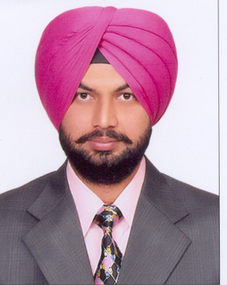
 | Designation | ASSISTANT PROFESSOR
 | Department | ELECTRICAL ENGINEERING
 | Date of joining | 17.01.2005
 | Qualification with class/Grade | M.TECH (Power Engg.) |  | 1st Div.
 | Total Experience Year | 09 Years
 | Papers Published | National Conference | International Conference |  |  | Journals
 |  | 10 | 01 |  |  | 02
 | Courses Attended | 11

 | Name of Teaching Staff | ARVIND DHINGRA |  |  | 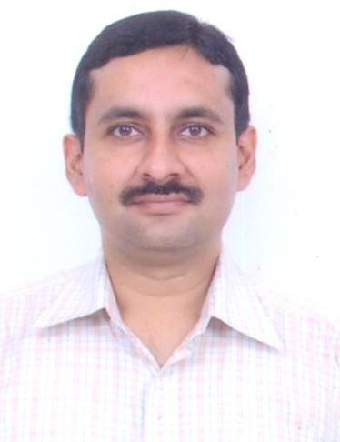
 | Designation | ASSISTANT PROFESSOR
 | Department | ELECTRICAL ENGINEERING
 | Date of joining | 26.7.2006
 | Qualification with class/Grade | M.TECH (Electrical) |  | 1st Div.
 | Total Experience Year | 18 Years
 | Papers Published | National Conference | International Conference |  |  | Journals
 |  | 33 | 39 |  |  | 09
 | Courses Attended | 33

 | Name of Teaching Staff | RAVINDER KAUR |  | 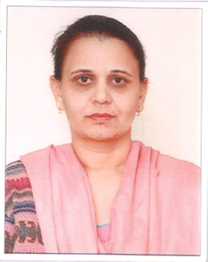
 | Designation | ASSISTANT PROFESSOR
 | Department | ELECTRICAL ENGINEERING
 | Date of joining | AUGUST 1994
 | Qualification with class/Grade | M.TECH (POWER ENGG.)
 | Total Experience Year | 14 YEARS
 | Papers Published | National Conference | International Conference |  | Journals
 |  | 01 | 01 |  | -
 | Courses Attended | 07

 | Name of Teaching Staff | SHIVANI ARORA ABROL |  | 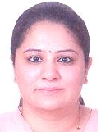
 | Designation | ASSISTANT PROFESSOR
 | Department | ELECTRICAL ENGINEERING
 | Date of joining | 5TH AUGUST 2011
 | Qualification with class/Grade | M.TECH
 | Total Experience Year | 10 YEARS
 | Papers Published | National Conference | International Conference |  | Journals
 |  | 06 | - |  | -
 | Courses Attended | 08

 | Name of Teaching Staff |  | GURPREET KAUR GILL |  |  |  | 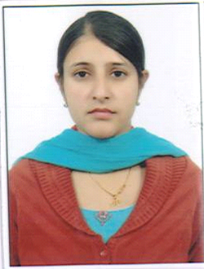
 | Designation |  | ASSISTANT PROFESSOR
 | Department |  | ELECTRICAL ENGINEERING
 | Date of joining |  | 1ST AUGUST 2011
 | Qualification with class/Grade |  | M.TECH (POWER)
 | Total Experience Year |  | 4 YEARS
 | Papers Published |  | National Conference |  | International Conference |  | Journals
 |  |  | 02 |  | - |  | 01
 | Courses Attended |  | 06
 |  | Name of Teaching Staff |  | SUKHDEEP SINGH BOPARAI |  |  |  | 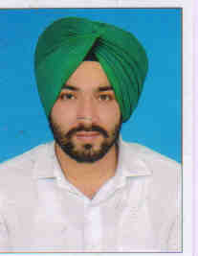
 |  | Designation |  | ASSISTANT PROFESSOR
 |  | Department |  | ELECTRICAL ENGINEERING
 |  | Date of joining |  | 02.08.2011
 |  | Qualification with class/Grade |  | M.TECH (Control Sys.) |  | 1st Div.
 |  | Total Experience Year |  | 03Years
 |  | Papers Published |  | Nil
 |  | Courses Attended |  | 10

 | Name of Teaching Staff | TARANDEEP KAUR |  | 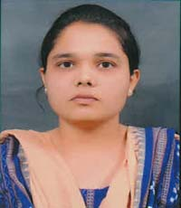
 | Designation | ASSISTANT PROFESSOR
 | Department | ELECTRICAL ENGINEERING
 | Date of joining | 16th AUGUST 2013
 | Qualification with class/Grade | M.Tech (power)
 | Total Experience Year | 1 years
 | Papers Published | National Conference | International Conference | Journals
 |  | 01 | 02 | -
 | Courses Attended | 03

 | Name of Teaching Staff | SAMREET KAUR GOSAL |  | 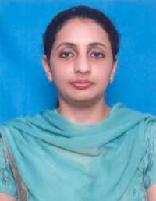
 | Designation | ASSISTANT PROFESSOR
 | Department | ELECTRICAL ENGINEERING
 | Date of joining | 12th September 2013
 | Qualification with class/Grade | M.Tech (control systems)
 | Total Experience Year | 4 years
 | Papers Published | National Conference | International Conference | Journals
 |  | - | - | -
 | Courses Attended | 08

